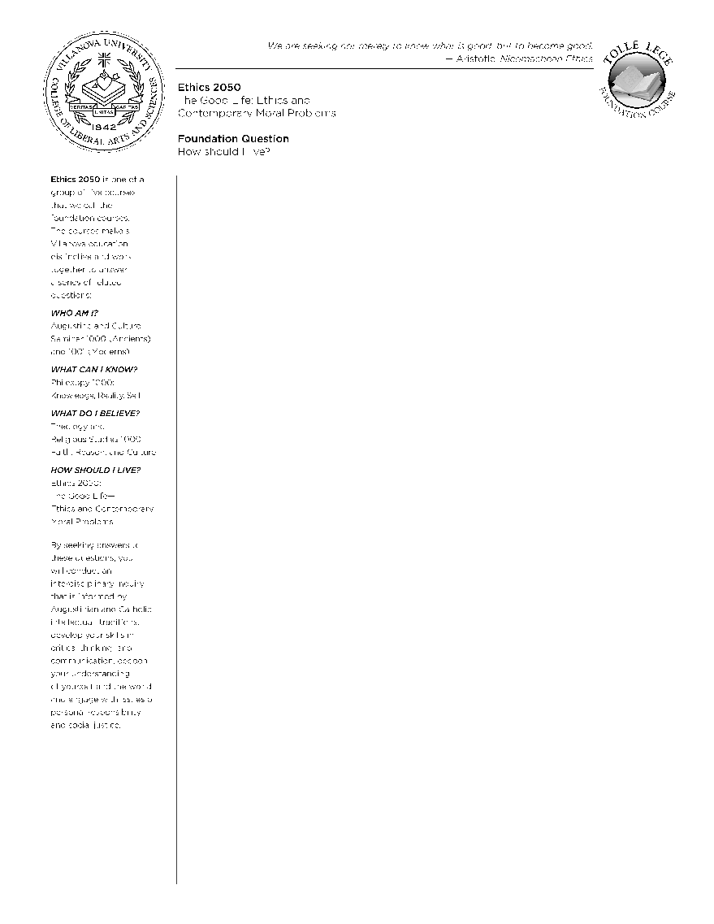
ETH 2050-017
Fall 2022
Tolentine Hall 416
Fall22-ETH-2050-017@villanova.edu
Ting Cho Lau, Ph.D. (He, Him, His)

Arthur J. Ennis Postdoctoral Scholar
Augustine and Culture Seminar Program
SAC 087
tlau@villanova.edu
813-760-4629

Office Hours
Connelly (by Holy Grounds)
Tuesday/Thursday: 1-3 pm (or by appointment)

Course Description: ETH 2050 involves students in the ongoing conversation about what constitutes the good life. That conversation involves ancient and modern thinkers, both philosophers and theologians, as well as people alive today, struggling with questions that each generation seeks to answer: What is the good life? What does justice demand of me? Does it matter what I believe about human nature, or about God, or about society when it comes to how I live my life? Is being happy the same thing as being a good person? How does one’s identity/ position in society impact how these questions are answered? One goal of the course is to provide students with “toe holds” into this longstanding conversation. Another goal is to enable students to engage these resources as they might bear upon some contemporary moral challenge and/or reality. These goals will be accomplished through a combination of the following: reading some challenging texts, examining some contemporary moral challenges, and writing essays designed to synthesize the insights of the first two activities.

Learning Goals
Content
- To advance understanding and critical reflection on the moral life as being especially concerned with human flourishing, i.e., with the nature of a good human life, the kind of life that is humanly worth living.
- To advance understanding and critical reflection on Christian and especially Roman Catholic, Augustinian accounts of a distinctive and viable vision of human flourishing that challenges and is challenged by alternative visions of the moral life in fundamental respects, with concern for the voices of underrepresented and/or marginalized groups.
- To explore the significance of those different approaches to the moral life through the examination of various contemporary moral questions, with concern for the voices of underrepresented and/or marginalized groups.
Skills
- The ability to read both primary and secondary sources carefully and critically (including state-of-the-art articles), so as to advance the conversation about the moral life with one’s peers.
- A capacity to engage in practical reasoning to arrive at reasoned judgment about some aspect of contemporary moral relations.
- The ability to write clear analytical papers that carefully defend a moral judgment while thoughtfully considering objections.
Covid-19 Policies
While the university has no mandatory mask policy, please feel free to wear one no questions asked. If a student prefers that everyone in class wears a mask, we will do so.
A student who must quarantine because of contracting Covid-19 or being in close contact with a person with Covid-19 will be responsible for any course work that they miss. Given the nature of the course as highly discussion heavy, I will not have a zoom option for absent students. I will work with any student to cover any material that they missed because of an absence.

Food and Drink in Class
Though class is not time for dinner, you’re free to eat anything in class that won’t bother other students (e.g., a muffin, granola bar, etc.). Water and other drinks are always permitted.

Communication
I use Villanova’s class e-mail lists for most communications. Please check your e-mail in the evening after class. I will typically send a recap e-mail with specific instructions on what to prepare for the next class. I am usually extremely prompt with e-mails (e.g., within a few hours or one day at maximum). That said, please be patient on the weekends or during particularly busy times (e.g., due dates for papers, final exams, the week before Fall and Winter break, etc.)

Academic Integrity/Plagiarism:
- As a member of Villanova’s academic community, you are expected to uphold the Academic Integrity Policy and Code, which you can view at the Academic Integrity Gateway website: http://library.villanova.edu/Help/AcademicIntegrity.
- Any incident of academic dishonesty will be reported to the Dean of the College of Liberal Arts and Sciences for disciplinary action.
- All work submitted in this course must be written for this course, not for another, and must be your own.
- Properly cite your sources.
- Do not cheat, plagiarize, or violate Villanova’s Academic Integrity Policy and Code. Intentional violation could result in the failure of the assignment or the course.
- Most importantly, do not cheat your own learning and development. If you need more time on an assignment and want to get things right, I’ll work with you.
Office of Disabilities and Learning Support Services
- Students with disabilities who require reasonable academic accommodations should schedule an appointment to discuss specifics with me.
- Present verification and register with the Learning Support Office by contacting (610) 519-5176 or learning.support.services@villanova.edu.
- For physical access or temporary disabling conditions, please contact the Office of Disability Services at (610) 519-4095 or email Stephen.mcwilliams@villanova.edu. Registration is needed in order to receive accommodations.
Mental Health and Counseling
- If you would like to receive counseling or would just like to talk to a mental health professional, the Counseling Center is available to help you with personal and emotional concerns. Appointments can be scheduled in person at 206 HSB or by phone at 610-519-4050. Counseling sessions occur between 9:30 a.m. and 4:30 p.m. weekdays. Services are available to all current Villanova students. Counseling is free and confidential.
  - Personal note: I have used such services as a student myself and it can be helpful. Just as it is a good idea to have check-ups on your physical body, it is also a good idea to have check-ups on your mental health.
Absences for Religious Holidays
- Villanova University makes every reasonable effort to allow members of the community to observe their religious holidays, consistent with the University’s obligations, responsibilities, and policies. Students who expect to miss a class or assignment due to the observance of a religious holiday should discuss the matter with their professors as soon as possible, normally at least two weeks in advance. Absence from classes or examinations for religious reasons does not relieve students from responsibility for any part of the course work required during the absence. https://www1.villanova.edu/villanova/provost/resources/student/policies/religious holidays.html
Attendance and Deadlines
- Due allowance is made for physical absences due to quarantine and complete absences for illness. Please do not come to seminar if you do not feel well.
- Given the participation requirements in the class and that it only meets twice a week, you are allowed 3 excused absences this semester. There is room for leeway given the pandemic and the potential need for quarantining or being cautious. For unexcused absences however, I may deduct a third of a grade for every two such absences.
- You are responsible for all work you have missed and must hand in missed assignments within one week of your absence in order to receive credit. If you have an absence due to official school business (e.g., sports, etc.), you can send a two-page written response to readings to satisfy your participation requirement.
- Submit work by the deadline. If there are extenuating circumstances and you would like to ask for an extension, notify me three days in advance. Unless you have been granted an extension, late work will be penalized one grade level per day past the due date.
Requirements and Grading
Short Writing Assignments 45%
- You will write three 3-4 double-spaced page writing assignments that help you reflect on the content of our readings.
Presentation 35%
- 15% - You and a partner in class will give an approximately 25 minute presentation on a moral issue of your choosing.
- 20% - Each of you will write a 2000 word paper on the topic that can be based on or can deviate from the presentation. Though you can share the same view as your partner, you cannot write the same paper.
Participation 15%
- Your participation contributes significantly to the classroom experience. Make sure you come to every class with specific observations or questions that you think might provoke discussion.
Oral Final Exam 5%
- Students will meet in groups of two to discuss the following two questions:
  - Which ethical matter are you most sure about now?
  - Which ethical matter are you least sure about now?
Grading Scale
- A—94-100—Exemplary—Consistently makes thoughtful comments during discussions based on careful reading of assigned texts. Writing assignments have nuanced arguments substantiated by textual evidence.
- A—90-93—Excellent—Attentive during discussions and frequently participates with questions/comments from the readings. Papers are insightful but contain occasional flaws or insufficient textual evidence.
- B+—85-89—Good—Comes to class consistently and listens respectfully during discussions but participates infrequently. Shows familiarity with the readings but writing but unable to articulate details from the text. Writing assignments show room for growth and sometimes lack proper textual evidence.
- Etc.
Additional Requirements
- Check your Villanova email account on a regular basis to ensure you do not miss important announcements.
- Check the course Blackboard page on a regular basis.
- Meet with me at least once this semester to discuss your writing.
- Visit the Writing Center at least once this semester (be sure to make an appointment in advance as they do fill up quickly—especially around exam time). This is 5% of your participation grade.
Guidelines for Submitting Written Work
All writing assignments should be completed by the beginning of class. You must both submit a digital copy via the SafeAssign tool on Blackboard and bring a paper copy to class.
When you complete a writing assignment outside of class you should:
- Type all written work in 12pt Times New Roman or some other serifed front (e.g., Garamond, etc.)
- Use double-spaced paragraphs and 1-inch margins.
- Number your pages at the bottom of the page.
- Include an appropriate heading on the first page with your name, the professor’s name, the title of the course, and the date.
- Proofread and spellcheck before bringing any drafts to class.
- Properly cite external sources according to a consistent citation system (e.g., Chicago Manual, etc.).
  - Example, cite the last name of the author and year like this: (Smith 2008).
- Save all files as Word documents and title them with your last name, course abbreviation, and the assignment title (i.e., Lau Ethics Essay).
Page requirements are a rough guide to the amount of detail and time I want you to spend on an essay. Be succinct and clear. Do not try to pad the paper to meet the page requirements (which are generally short).

Writing Center:
- The University Writing Center is a valuable resource that can help you at any stage in the writing process. You must make and attend at least one appointment with the University Writing Center. Make use of the free resource! In addition to one-on-one tutoring, you might also attend the 30-Minute workshops or utilize their online resources.
Tech policy
You are paying good money for this education. I have every intention of giving you your money’s worth. If you don’t text during a movie that you paid $10 to watch, why would you text during a class you’ve paid far more to attend?
Bring paper copies of the text to class. If you want to use a laptop or some other electronic device for texts or notetaking, do the following:
- Disconnect the WiFi so that you refrain from checking e-mail, social media, news, etc.
- I recommend bringing a paper notebook to write down observations, ideas, and questions. Physically writing something down helps with the learning process.
- Engage actively in class. If I’m doing my job right and you are trying your best, you shouldn’t be tempted to check Tiktok on your phone. We’re in it together.
Required Texts Ethics:
- The Essential Writings. Edited and with an Introduction by Gordon Marino. New York: Modern Library, 2010.
- Moral Theory: An Introduction (Second Edition). Mark Timmons. Rowman and Littlefield, 2010
- PDFs available on Blackboard
Tentative Course Schedule
All reading will either be available online on blackboard as a pdf or in your coursebooks.
Readings are subject to change. Please be sure to check recap e-mails for reading assignment.

Theoretical Foundations
Week 1 Introduction to Ethics
8/24
- Midgley – “Trying Out One’s New Sword” – (Marino 321-327)
Week 2 Virtue Theory
8/29
- Aristotle – Nicomachean Ethics – (Marino 43-84)
- Supplement – Timmons Chapter 10
8/31
- Augustine – City of God Book 19 selections
- Confucius – Selections from the Analects
Week 3 Christian Ethics
9/7
- Pope Francis Fratelli Tutti (selections)
- Supplement: Bible for Normal People Podcast
Short Paper 1 Due 9/11

Week 4 Consequentialism
9/12
- Mill Utilitarianism (Marino 225-255)
- Supplement: Timmons Chapters 5 & 6
9/14 Singer – Famine, Affluence and Morality
Week 5 Kantianism
9/19
- Kant Fundamental Principles of the Metaphysics of Morals (Marino 188-224)
- Supplement: Timmons Chapter 8
9/21
- Korsgaard - “A Kantian Account of our Obligation to Animals” (audio or chapter 8 of fellow creatures
- Supplement: Peter Godfrey Smith “Philosophers and Other Animals”
Week 6 Moral Foundations and Moral Saints
9/26
- MLK – “Letter from a Birmingham Jail” (Marino 356-377)
- Rorty – “Pragmatism, Relativism, and Irrationalism”
9/28
- Wolf – “Moral Saints” (Marino 462-485)
Short Paper 2 Due 10/2

Political Applications

Week 7 Political Philosophy and Voting
10/3
- Rawls- Theory of Justice (Marino 378-395)
- Dreher – Selections from The Benedict Option
10/5
- Brennan – “The Right to a Competent Electorate”
- United States Conference of Catholic Bishops, “Forming Consciences for Faithful Citizenship: A Call to Political Responsibility” (sections 31-43)
Week 8 Morality and Markets
10/17
- Friedman – “The Social Responsibility of Business is to Increase its Profits”
- Pope Francis – Laudato Si (chapter 3 and 4)
10/19 Anderson – Chapter 2 of Private Government

Week 9 Race and Reparations
10/24
- Haslanger “Tracing the Sociopolitical Reality of Race” in What is Race?
- Spenser “How to Be a Biological Racial Realist” in What is Race?
10/26 Olufemi – Chapter 3 of Reconsidering Reparations
Short Paper 3 Due

Further Applications (flexible)

Week 10 Friendship and Romantic Love
10/31
- Aristotle on Friendship (Nicomachean Ethics Book 7)
- Cocking and Kennett “Friendship and Moral Danger”
11/2
- Lau “Possessing Love’s Reasons”
Week 11 Medical Ethics
11/7
- Barnes “Valuing Disability, Causing Disability”
- Hawkins “Dignity Beyond Accomplishment”
11/9
- Judith Jarvis Thomson “A Defense of Abortion”
- Supplement: IEP on Abortion

Week 12 Games and Technology
11/14
- Nguyen – “Games and the Art of Agency”
11/16
- Bostrom – “Are We Living in a Computer Simulation?”
Week 13 Aesthetics
11/21
- Lau “Rethinking Low, Middle, and High Art”
Student Presentation Topic Proposals Due 11/21

Student Presentations

Week 14 (Week 1 of Presentations)
11/28
11/30

Week 15 (Week 2 of Presentations)
12 /5
12/7

Week 16 Conclusion
12/12 Wrap-Up

